**Vision Of Vacation**

**Introduction**

**Purpose:**

This document is meant to delineate the features of Vision Of Vacation, so as to serve as a guide to the developers on one hand and a software validation document for the prospective client on the other. Vision Of Vacation has been developed with a core idea of making an user friendly web interface which would decrease the communication gap between the service provider and the customer.

**Scope**:

It consists of three main modules i.e. Administrator, Service Provider and the Customer. The Administrator has the right to approve the service provider or may also delete the service provider. The service provider can add their new services, update the existing ones or delete them too. The service provider can also add more than one services. The customer can view the services available to them and also book from the variety of the services available.

Definitions:

VOV --> Vision Of Vacation

SRS --> Software Requirement Specification

GUI---> Graphical User Interface

Portal--> Personalized Website

Stakeholder --> The person who will participate in the System. And Owner of system

Ex. Customer, Administrator , Service Provider

UML---> Software Engineering Notation for visualising System in the form diagrams

SSL--- > Secure Socket Layer used for providing restricted access to application.

RDBMS --> Relational Dadabase Management System.

CLUSTERS---> Group of independent servers.

**Overview:**

The system provide easy to access interface gives the travel company a platform to showcase all their available services and the customers a choice to choose from a variety of services available to them from all over.

**Additional Information:**

The system work on internet server, so it will be operated by any end user for booking services purpose with secure platform.

**General Description:**

The Vision of Vacation application helps to manage the services and also helps customer to book the services.

The online shopping system will use the internet as the providing services to customer.

**Functional Requirement:**

This section provides requirement overview of the system. Various functional modules that can be implemented by

The system will be-

Description:

Login Customer logins to the system by entering valid user id and password .

Customer can select one of the category and subcategory shown on the home page. Based on the subcategory selected all the services registered under it is shown to the customer. Customer can book one of the service, while booking the service Customer needs to register, and the customer can do the payment for the booked service using debit or credit cards.

Customer can search service based on selected city also.

**Technical Issues:**

This system will work on client-Server architecture. It will require an internet server.

The system should support some commonly used browser such as Chrome etc.

Interface Requirement Various interfaces for the services could be

1. Login Page,

2. Registration form

There will be a screen displaying information about services that the provider have.

The customers may select the different options which will be open in another screen as

1 .Login Page

2 . Registration Form

3 .Category and subcategory page

4 .List of services under selected category

5.Booking services page

6.Payment Gateways

Hardware Interface:

The System must run over the internet,

All the hardware shall require to connect to internet will be hardware interface for the system.

e.g. modem, WAN, LAN

Specialized Server Infrastructure Hardware

The system should use distributed servers i.e. cloud for managing large amount of data so as to make it appear as single unit for end-user.

The system should have proper clusters for backup.

**Software Interface:**

The system is on server so it requires the any scripting language like JSP or PHP or ASP, ETC.

The system should be able to exchange data using XML, JASON or any advance technology.

The system require Database also for the store the any transaction of the system like MySql or oracle, or SQL server etc.

System also require DNS (Domain Name space) for the naming on the internet.

http://www.transflower.in

http://www.amazon.in

At the end-user need web browser for interact with the system.

**Performance Requirement**:

There is no performance requirement in this system, because the server request and response to client is totally based on internet connection of end-user.

**Design Constrains:**

This system should be developed using Standard Web Page Development Tool , which conforms GUI standards such like HTML, XML, JSON ,etc.

The system should support various RDMS and Cloud Technologies.

**Non-Functional Requirements**

1. Security:

SSL

The System use SSL (Secure Socket Layer) in all transactions that include any confidential customer information. The system must automatically log out all customers after a period of inactivity. The system should not leave any cookies on the customer's computer containing users’ password. The system's back-end servers shall only be accessible to authenticated administrators. Sensitive data will be encrypted before being sent over insecure connections like internet.

The proper firewalls should be developed to avoid intrusions from the internal or external sources.

2.Reliability:

The system provides storage of all databases on redundant computers with automatic switchover. The main pillar of reliability of the system is the backup of the database which is continuously maintained and update to reflect the most recent changes.

3: Availability:

The system should be available at all times. meaning the user can access it using web browser, only restricted by the down time of the server on which the system runs. In case of a of a hardware failure or database corruption, a replacement page will be shown. uptime : It mean 24 * 7 availability

100%--------------

99.9%

99.999%

99.9999%

4: Maintainability:

A commercial database is used for maintaining the databae and application server takes care of the site. The maintainability can be done efficiently.

5.Portability:

The application is HTML and scripting language based (Javascript). So the end user part is fully portable and any system using any web browser should be able to use the features of the system ,including any hardware platform that is available or will be available in the future. An end-user is used this system on an OS; either it is Windows or Linux. The System shall run on PC, Laptops and PDA.etc. The technology should be transferable to different environments easily.

6.Accessibility:

Only registered users should be allowed to process the orders after authentications. Only GUI access of the system should be permitted to end users.

7.Policies:

The system should adhere to all the legal formalities of the particular countries. The system should maintain security related to sensitive data.

8.Efficiency:

The system should provide good throughput and response to multiple users without burdening the system by using appropriate number of servers.

9.Safety:

Software should not harm ethical and environmental conditions of the end users machine.

10.Modulariy:

The system should have user friendly interface.

It should be easily updated, modified and reused.

Operational Scenario:

Customer Interaction:- Based on the category and subcategory or city which user selects the system suggests vacation spots ,provides various attractions at the destination such as Adventure sports, tourist places or even a just place to stay. When a user selects particular service, details about the service are provided. The user must be registered before he books a service. On booking, a mail regarding it is sent to both user and the service provider.

Preliminary Schedule:

1) Login

2) Select category and subcategory or city

3) Manage customer database Browse category

4) Booking of service

5) Registration

6) Cancel service booking

7) Payment

8) Give feedback

9) Logout

Use Case Daigram:->

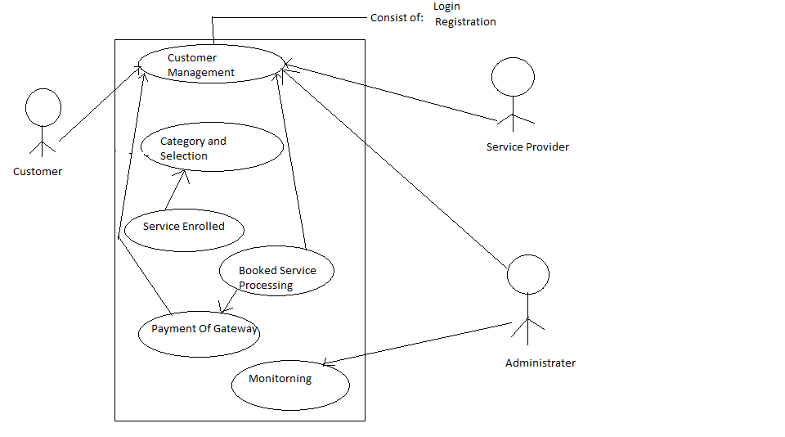



Modules:-

1. User Management-

-> Customer require registration to book the services

->Admin needs to login to approve the service provider or may also delete the service provider.

->Service provider requires registration to showcase their service.

->Authentication and authorization

-->Register and login of customer,

-->Login of Admin

-->Service provider registration

2. Category and Subcategory or city selection->

Customer can select one of the category and subcategory shown on the home page. Based on the subcategory selected all the services registered under it is shown to the customer. Customer can search service based on selected city also.

3.Service enrolled: ->

The service provider can add their new services, update the existing ones or delete them too. The service provider can also add more than one service.

4. Payment Processing :->

After the services have been booked the payment details are taken from customer and processed.

5. Booked service processing :->

Once the services have been booked by the customer, the system generates the confirmation mail to both the customer as well as the service provider.

List of tables

1)Customers--->

->CustomerId (primary key), CustomerName, Address, Email, Phoneno

2) Administrator-

-> AdminName,Password.

3) Providers-->

->ProviderId(primary key),ProviderName,Email,Password,Phoneno

4) Services enrolled->

->Id(primary key),city,description,price,rating,timing,CategoryId(foriegn Key),Provider_Id (foriegnKey),SubCategory_Id(foriegn Key)

5) Subcategories->

->CategoryId(froiegn key),SubCategoryName,description,SubCategorgy_Id(primary key)

6) Categories-->

->CategoryId(primary key),CategoryName,Description